**DAILY ONLINE ACTIVITIES SUMMARY**

|  |  |  |  |  |  |  |  |  |
| --- | --- | --- | --- | --- | --- | --- | --- | --- |
| **Date:** | **07-06-2020** | | | | | **Name:** | **Shiza Amreen.J** | |
| **Sem & Sec** | **4th sem B sec** | | | | | **USN:** | **4AL18CS078** | |
| **Online Test Summary** | | | | | | | | |
| **Subject** | | **-** | | | | | | |
| **Max. Marks** | | **-** | | **Score** | | | **-** | |
| **Certification Course Summary** | | | | | | | | |
| **Course** | **Introduction to Cyber Security** | | | | | | | |
| **Certificate Provider** | | | **GreatLearning** | | **Duration** | | | **5.5 Hours** |
| **Coding Challenges** | | | | | | | | |
| **Problem Statement:** [**Write a C++ Program to swap two numbers using friend as a bridge concept.**](https://github.com/orgs/alvas-education-foundation/teams/2nd-year/discussions/106) | | | | | | | | |
| **Status: Completed** | | | | | | | | |
| **Uploaded the report in Github** | | | | | **yes** | | | |
| **If yes Repository name** | | | | | **Lockdown_Coding** | | | |
| **Uploaded the report in slack** | | | | | **yes** | | | |

Certification Course Details: 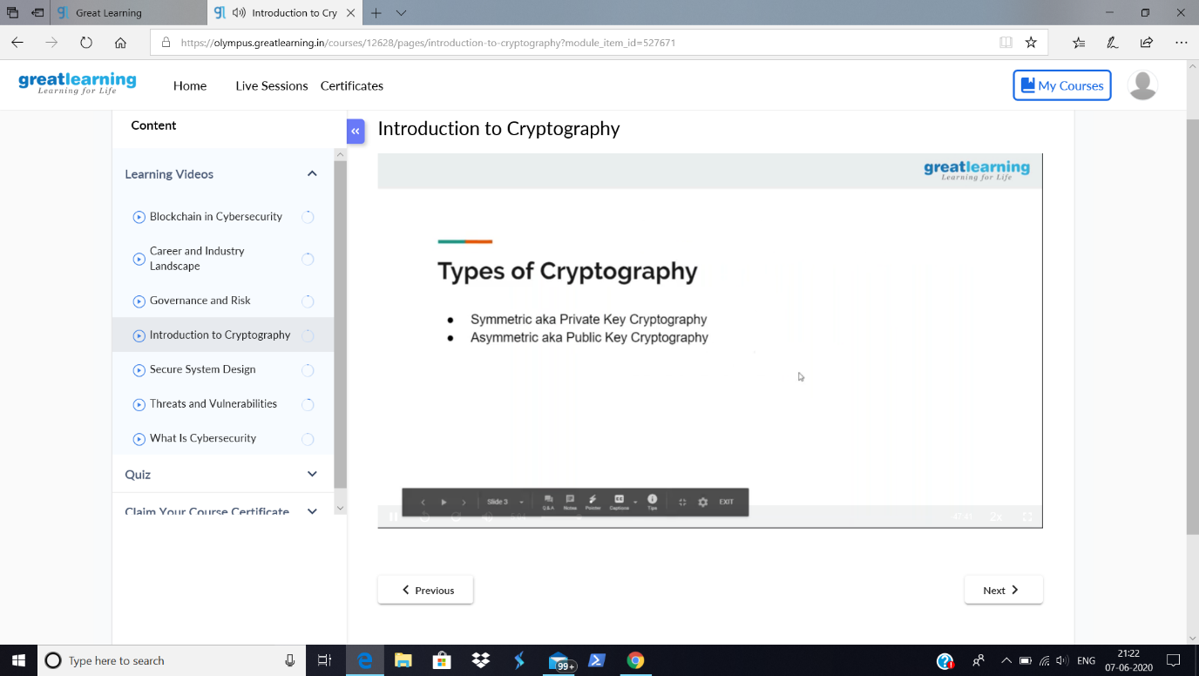

Today in the course, I have learnt about the Types of Cryptocurrencies in Introduction to Cyber Security.

Coding Challenges Details:

**Problem Statement:** [**Write a C++ Program to swap two numbers using friend as a bridge concept.**](https://github.com/orgs/alvas-education-foundation/teams/2nd-year/discussions/106)

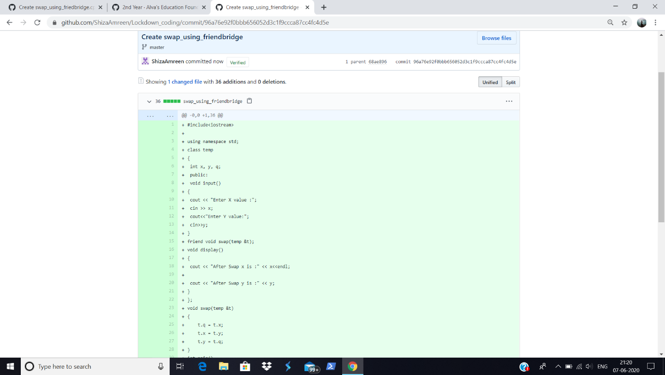

**I have written the code for above given problem statement and uploaded it in my github repository, Lockdown_Coding**

<https://github.com/ShizaAmreen/Lockdown_coding/commit/96a76e92f0bbb656052d3c1f9ccca87cc4fc4d5e>